24.52: a) System acts like two capacitors in series so 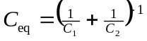

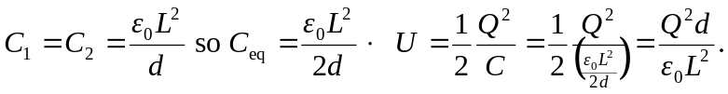

b) After rearranging, the E fields should be calculated. Use superposition recalling 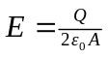for a single plate (not 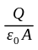 since charge Q is only on one face).
between 1 and 3: 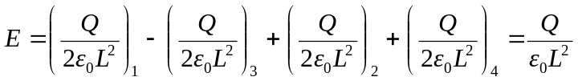

between 3 and 2: 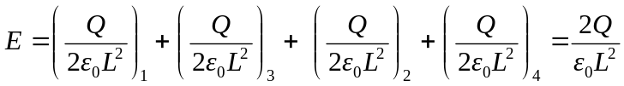
between 2 and 4: 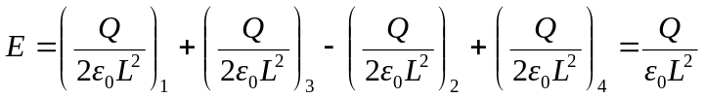
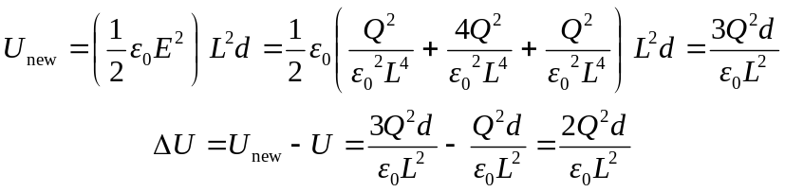
This is the work required to rearrange the plates.

